Youth Zone Survey Results
April 2, 2025

All individuals active with the 412 Youth Zone had the opportunity to participate in a survey in February 2025. Surveys could be completed on paper or online through SurveyMonkey. Respondents had the option to provide their name to be entered in a raffle for one of five $25 gift cards, but they could also complete the survey anonymously.

194 unique youth (of 584 total active) responded to the survey, for a response rate of 33%. Most respondents were age 18 or older. Forty-six percent of the respondents who reported their age were between 18 and 20 years old, and 38% were 21 to 23 years old. Only 16% were 16 or 17 years old.

Survey Respondents by Age
Age | Count
16-17 years old | 27
18-20 years old | 77
21-23 years old | 64
Unknown | 26
Total | 194

More females responded to the survey than males, but males are better represented among survey respondents than in prior years. Twelve transgender and non-binary youth also responded to the survey (7%). As represented in the table below, youth of all genders selected a variety of terms to describe their sexual orientation. Young women were more likely than their male peers to report identifying as LGBQ (54% v. 29%). Forty-two percent of respondents identified as LGBTQ in some way.

Survey Respondents by Gender and Sexual Orientation
 | Female | Male | Non-binary | Total
Number of Youth | 86 | 71 | 12 | 169
Heterosexual/Straight | 35 | 44 | 1 | 80
Bisexual | 22 | 7 |  | 29
Gay, Lesbian, or Same Gender Loving | 7 | 4 | 4 | 15
Asexual | 8 | 5 |  | 13
Pansexual | 3 | 1 | 3 | 7
Queer |  |  | 2 | 2
Demisexual | 1 |  |  | 1
I am not sure yet |  | 1 | 2 | 3
I don’t understand the question | 3 | 2 |  | 5
No answer provided | 7 | 7 |  | 14

The tables below display respondents’ racial identities and genders. Please Note: Youth Zone participants’ racial identities cannot neatly be summarized because there is a lot of diversity within their multiracial identities. Therefore, the first table shows the demographics of all youth summarized at a high level. The table after that shows how many youth identify with certain ethnic and racial backgrounds. In the second table, many youth are represented more than one time.

About 57% of survey respondents identified as Black, 22% as White, and 17% as Multi-Racial. The demographic breakdown of youth responding to the survey is very similar to 2024, with one notable exception—the number of responses from Black males doubled this year compared to last year.

Approximately one in three survey respondents were Black females. Sixty-six percent of all respondents identify as Black, either as their full identity or as one part of their multiracial identity. Similarly, 27% of youth fully or partially identify as White, 5% as Native American or Native Hawaiian, 4% as Hispanic or Latinx, and 3% as Asian. Eleven percent of youth selected the term “multiracial” as either the sole term or one among others that they use to describe their racial or ethnic identity. This distribution of racial identities among respondents is consistent with those of survey respondents in prior years.

Youth by Race and Gender (all Youth are Counted Once)
 | Female | Male | Trans, Non-binary | Total | Percent
Black | 49 | 45 | 2 | 96 | 57%
White | 20 | 12 | 6 | 38 | 22%
Multi-Racial | 14 | 12 | 3 | 29 | 17%
Other single racial identity | 2 | 1 |  | 3 | 2%
Prefer not to answer | 1 | 1 | 1 | 3 | 2%
Total | 86 | 71 | 12 | 169 | 100%

Youth with Full or Partial Racial Identities As… (Some Youth Are Counted Multiple Times)
 | Female | Male | Trans, Non-binary | Total | Percent
Black | 56 | 52 | 3 | 111 | 66%
White | 24 | 14 | 7 | 45 | 27%
Multiracial | 9 | 6 | 3 | 18 | 11%
Native American or Native Hawaiian | 5 | 2 | 1 | 8 | 5%
Hispanic or Latinx | 4 | 3 |  | 7 | 4%
Asian | 3 | 2 |  | 5 | 3%

FINDINGS

Relationships with Coach

Ninety percent of youth reported their coaches were trustworthy, and 91% indicated their coach values their opinions about their life Often or All of the Time (top 2 options on a 5-point scale). While the ratings this year are slightly lower than in prior years, the difference is minimal. Youth consistently rated their coaches well nine times out of ten, which is within a range consistent with prior surveys.

Among the small number of responses where youth did not rate their coaches in the top two categories, most scores indicated their coach Sometimes exhibits the listed characteristic, with a small number of youth saying their coach Rarely or Never exhibits some of these qualities. No coaches had more than one respondent provide a negative review.

Satisfaction Ratings for Youth Coaches Over Time
My Youth Coach… | Percent Often or All of the Time
 | Sep-19 | Mar-22 | Feb-23 | Feb-24 | Feb-25
 | n=154 | n=103 | n=128 | n=142 | n=167
Is trustworthy | 94% | 91% | 95% | 95% | 90%
Is reliable | 92% | 90% | 88% | 93% | 89%
Values my opinions about my life | 94% | 91% | 91% | 93% | 91%
Is available to me when I need them | 85% | 88% | 88% | 91% | 88%
Makes me feel heard and understood | 92% | 90% | 92% | 91% | 89%

The majority of youth communicate with their coaches weekly or monthly. The percent of survey respondents who reported having contact with their coach at least weekly (first two categories combined) dropped from 58% in 2024 to 46% in 2025. However, the percentage of youth reporting being satisfied with the frequency of their communication with their coach remained the same at 87%.

Most of the 19 youth who reported that their communication is Not Enough reported communicating with their coach monthly or less than once per month. The majority of them report being in stable housing. They have different coach assignments, and they are a diverse group with a variety of employment and education statuses. However, females, LGBTQ youth, Black youth, and Native American youth are overrepresented in this group.

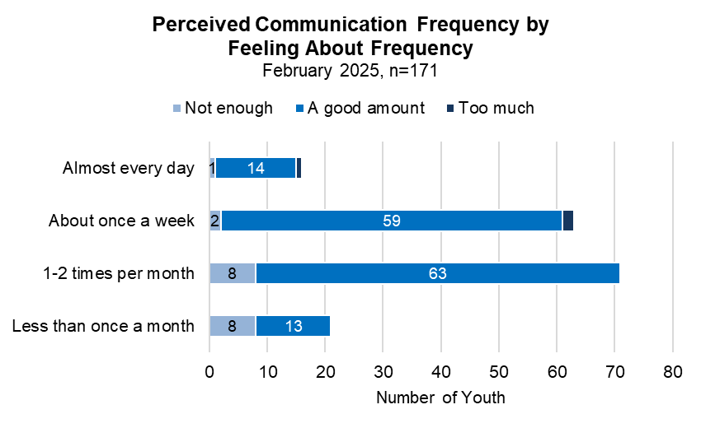
Stable Housing

Survey respondents were asked to describe whether their current housing is safe and stable, meaning they can stay there for at least the next 90 days. Four-fifths of youth respondents indicated they currently live in safe and stable housing, but one in five do not. Most youth who are unstably housed reported being somewhere safe that they could not stay, followed by youth indicating they have nowhere to stay.

Youth with unstable housing were then asked where they are currently sleeping (from a list of options with the opportunity to self-describe). A majority indicated they are currently staying at home, which included living with friends or family. The next most common sleeping locations were homeless shelters and couch surfing. Different from last year when only one young person reported sleeping in their car, four youth indicated they were sleeping in abandoned buildings or outside (not in a vehicle).

Housing Status and Current Sleeping Arrangements
 |  |  | Current Sleeping Arrangements
Housing Status | Number of Youth | Percent | Home, w/ Family | Homeless shelter | Couch surfing | Outside or abandoned building
Safe and stable housing† | 146 | 80%
Safe, but cannot stay | 17 | 9% | 8 | 4 | 4 | 1
Can stay, but unsafe | 5 | 3% | 3 | 1
Nowhere to stay | 14 | 8% | 7 | 3 | 3 | 3
Total | 182 | 100% | 18 | 8 | 7 | 4
† Four youth who indicated they have stable housing reported sleeping at a homeless shelter. Another three indicated they live in a group home.

Regardless of their current living situation, if youth experienced unstable housing in the prior six months, they were asked to share why. The table below displays the answers by age. The most common reasons youth experienced unstable housing were because their friends or family no longer allowed them to stay with them, or they felt unsafe at home—85% of youth who had unstable housing selected at least one of those two reasons. Less than one-fourth of youth with unstable housing reported losing their housing due to eviction.

Reasons for Unstable Housing in the Past 6 Months, by Age¹
 | 16-17 years old | 18-20 years old | 21-23 years old | Unknown | Total
No unstable housing in past 6 months | 16 | 43 | 39 | 6 | 104
Total youth reporting unstable housing | 9 | 17 | 19 | 2 | 47
Family/friends no longer let me stay with them | 4 | 7 | 11 | 2 | 24
I left where I was living because I felt unsafe | 4 | 10 | 7 | 1 | 22
Evicted, didn’t/couldn’t pay rent | 1 | 3 | 2 | 2 | 8
Evicted, other reason |  |  | 3 |  | 3
Other: | 1 | 2 | 3 | 1 | 7
Lease ended, not renewed |  |  | 2 |  | 2
¹ Youth could report more than one reason for experiencing unstable housing.

Employment and Education

Youth were asked to report on whether they are attending school, working, and if not working, trying to find a job. The self-reported employment and education statuses of youth are represented in the figures below. Some summary statistics include:
- 53% of all respondents reported being enrolled in school
- 44% of all respondents reported being employed (54% of these youth are also enrolled in school)
- 78% of respondents who are in school and unemployed are looking for a job
- 68% of respondents who are not in school and are unemployed are looking for a job
- 26% of respondents are both not in school and unemployed; 9 of these 50 youth report not completing high school or a GED program

About two-thirds of the youth who are currently enrolled in school are in high school. When excluding the youth who report being enrolled in high school, 85% of youth have their high school diploma or GED. Eighteen percent are currently enrolled in higher education or have already received a college degree or certification.

Educational Enrollment and Attainment
 | Level of Education | Total | Percent of All Youth
Currently Enrolled in School | Graduate School | 4 | 2%
 | College/Votech | 28 | 15%
 | GED Program | 1 | 1%
 | High School | 69 | 36%
Highest Level Completed for Youth Not in School | Total Not in School | 89 | 47%
 | College Degree or Certificate | 2 | 1%
 | Some College | 6 | 3%
 | HS Diploma or GED | 66 | 35%
 | Some High School | 12 | 6%
Total |  | 191 | 100%

The unemployment rate for respondents not enrolled in school (53%) is slightly higher than the unemployment rate of youth enrolled in school (47%), many of whom are in high school. This survey does not capture whether the young adults who are not working or enrolled in school have other sources of income, but it does reveal that 72% of youth who are not working are looking for employment (down from 80% last year), and 49% of all respondents reported leaving a job in the past year.

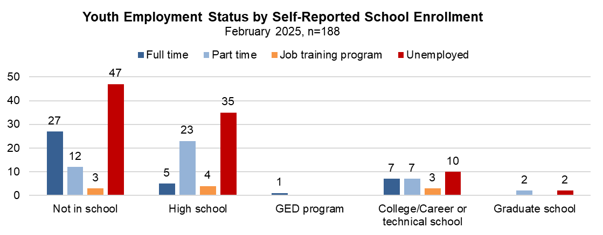

Of the 44% of survey respondents that reported being employed, 31% have been at their job for six months or longer. Forty-two percent have been at their jobs for fewer than three months.

Length of Employment for Youth Currently Employed
 | Full time | Part time | Total
Less than 3 months | 16 | 18 | 34
3 to 6 months | 11 | 11 | 22
More than 6 months | 11 | 14 | 25
Total | 38 | 43 | 81
Youth who are not enrolled in school reported being at their job for less than three months at a much higher rate than youth who are in school. As displayed in the table below, rates of full-time versus part-time employment vary by age, with older youth more likely to hold full-time positions.

Employment Status by Age
 | 16-17 years old | 18-20 years old | 21-23 years old | Age Unknown | Total
Full time |  | 15 | 19 | 6 | 40
Part time | 10 | 21 | 9 | 4 | 44
Job training program | 1 | 6 | 4 |  | 11
Seeking Employment | 1 | 2 | 1 |  | 4
Not working | 16 | 34 | 33 | 14 | 97
Seeking Employment | 13 | 21 | 25 | 11 | 70
Total | 27 | 76 | 65 | 24 | 192

If survey respondents had trouble finding a job in the prior twelve months, they were asked to share some of the reasons they thought were contributing to these challenges. Youth were offered a multiple-choice list of reasons, and they could also add their own reasons. Reasons given by two or more youth are listed in the table below.

The most common challenge identified, reported by 32% of youth, was transportation issues (down from 44% in prior years). Twenty-eight percent of youth indicated they do not understand why their attempts to secure employment are unsuccessful (down from 37% the last two years). In addition to fewer youth reporting these most common reasons as barriers, the number of youth reporting drug or alcohol use as a barrier dropped from 7% last year to only one respondent this year.

Reasons Youth Have Trouble Finding Jobs (Reasons Given by 2 or More People)
 | Total Youth | Percent of Respondents* (n=103)
Transportation issues | 33 | 32%
I don’t know. I am applying and not getting called | 29 | 28%
Mental or physical health | 23 | 22%
Limited work experience | 18 | 17%
Childcare/parenting challenges | 17 | 17%
Weak references | 11 | 11%
Interview skills | 9 | 9%
Lack of high school diploma/GED | 8 | 8%
Criminal background | 6 | 6%
Something else: (please describe)
Disability | 3 | 3%
School | 2 | 2%
Note: Youth could select more than one option

The third most common reason, which increased substantially from last year (13%) to a similar level seen in 2023 (24%), was physical or mental health issues. All of the youth reporting health issues as a barrier to employment were 18 or older, and youth of all gender and racial identities were represented in this group. There are no discernable patterns among this group of youth.

If the survey respondent lost or left a job in the past year, they were asked to share the reason(s). Young adults ages 21 to 23 reported leaving their jobs at higher rates than younger youth. Of the respondents who provided at least one reason for leaving, 42% reported quitting for a variety of reasons—a bad work environment being the most common, followed by not receiving enough pay or hours. Thirty-seven percent reported they left because they found a better job. Twenty-four percent of youth who left a job did so because the job was seasonal or temporary. This group was demographically diverse, with no group clearly being overrepresented.

Reasons Youth Lost or Quit a Job in the Past Year (Reasons Given by 2 or More People)
 | Total Youth | Percent of Youth Who Left a Job (n=93)
Quit | 39 | 42%
Bad work environment | 11 | 12%
Not enough hours, pay | 6 | 6%
School, sports | 5 | 5%
Moved to a different area | 3 | 3%
Transportation issues, too far away | 3 | 3%
Assaulted at work, unsafe | 2 | 2%
Mental health issues | 2 | 2%
Other reason quit | 2 | 2%
Found a better job | 34 | 37%
Seasonal | 22 | 24%
Fired - Missed work | 12 | 13%
Pregnant or Parenting Responsibilities | 10 | 11%
Fired: Poor performance or behavior | 7 | 8%
Other reason lost job | 8 | 9%
Illness | 3 | 3%

TRANSPORTATION

Youth were also asked about whether they have a driver’s license and the type of transportation they rely on for work. Thirty percent of all respondents indicated they have a driver’s license, and an additional 9% have their learner’s permit. The likelihood a young person has their license increases with age. About 1 in 3 respondents ages 21 to 23 currently have a driver’s license. Compared to last year, the same percentage of youth report having neither their license or permit, but among the youth who’ve started the process to get their license, more youth this year report having their license versus a learner’s permit.

Driver’s License Status by Age
Driver’s License? | 16-17 years old | 18-20 years old | 21-23 years old | Unknown | Total
Number of Youth | 26 | 75 | 64 | 25 | 190
Yes | 19% | 28% | 42% | 16% | 30%
Learners Permit | 15% | 4% | 9% | 20% | 9%
No | 65% | 68% | 48% | 64% | 61%
Total | 100% | 100% | 100% | 100% | 100%

Of those with a driver’s license, about half regularly have access to a reliable vehicle. About one-fourth have their own reliable vehicle, and another fourth share a vehicle or can borrow one when needed.

Drivers’ Access to a Reliable Vehicle by Age
Access to a Reliable Vehicle? | 16-17 years old | 18-20 years old | 21-23 years old | Total
I have my own reliable vehicle | 1 | 6 | 6 | 13
I share a reliable vehicle with someone else | 1 | 4 | 3 | 8
I can borrow a car when I need to | 1 | 2 | 2 | 5
I have my own vehicle, but it often breaks down or needs repairs. |  | 1 | 1 | 2
I do not usually have access to a reliable vehicle. | 2 | 8 | 15 | 25
Total | 5 | 21 | 27 | 53

All youth were asked about the primary way they get to work when they are employed. The majority rely on public transportation. Three out of five youth indicated they rely on the bus, and another 15% indicate they use a mixture of methods that do not include them driving themselves (public transportation, walking, rides from others, and rideshare). Only about one in ten youth report driving themselves to work.

Primary Way Youth Get to Work
 | Total | Percent
Bus or other public transportation | 111 | 60%
No-Car Combination: Bus, rideshare, getting rides, walking† | 28 | 15%
Driving myself | 17 | 9%
Getting rides from someone else (coworker, family, friend, etc.) | 16 | 9%
Walking, biking, scooter, etc. | 5 | 3%
RideShare app (Lyft, Uber) | 4 | 2%
Combination with Car: Drive myself, bus, getting rides, rideshare† | 3 | 2%
Total | 184 | 100%
† Respondents were asked to select their primary method of transportation, but some youth completing the paper survey selected multiple options. They are grouped here according to whether the individual sometimes drives.

Voting

For the first time this year, youth were asked to report on whether they are registered to vote, and if not, the reasons why. Two-thirds of all respondents indicated they are registered to vote, with significantly more 21- to 23-year-olds being registered than youth ages 18 to 20. The rates of registration are the same for youth identifying as male and female (69%), but only 40% of transgender and non-binary youth are registered to vote.

White youth reported lower rates of registration (57%) compared to youth of other racial and ethnic identities (70%). This is largely due to the difference in registration rates between Black females (79%) and White females (47%).

Self-Reported Voter Registration by Age
 | 18-20 years old  n=76 | 21-23 years old  n=64 | Total  n=140
Registered to Vote | 57% | 80% | 67%
Not Registered | 43% | 20% | 33%
Total | 100% | 100% | 100%

The most common reason youth provided for not registering to vote is that they believe their vote won’t make a difference. The next most common reason was that they do not understand politics. Seven of the youth who gave a reason (15%) indicated that they did not know how to register.

Reasons Youth Report Not Registering to Vote
 | 18-20 years old | 21-23 years old | Total
My vote won't make a difference | 12 | 7 | 19
I do not understand politics | 6 | 4 | 10
I do not know how to register | 7 |  | 7
I am not old enough to vote | 1 |  | 1
Other reason: | 5 | 1 | 6
Not interested/don’t want to | 3 | 1 | 4
Never registered | 2
Total | 33 | 13 | 46

On the paper surveys, eight individuals who reported being registered to vote also checked a box for a reason they were not registered. This may indicate they’re registered but unlikely to vote. Four of the seven indicated they believe their vote won’t make a difference.

Zone Experience

This survey includes questions to better understand participants’ experiences at the Zone, as well as how youth perceived the services provided by Zone staff to be beneficial to them. Seventy-one percent of respondents fully agreed that support from the Youth Zone helps them to stay focused on their goals. There appears to be a mild correlation between attendance at the Zone and youth reporting that the Youth Zone helps them stay focused on their goals: 93% of youth who report attending the Zone at least monthly Agree or Somewhat Agree that the Youth Zone helps them stay focused on their goals, compared to 80% percent of youth who report attending the Zone Never or Less than once per month. Youth who rarely or never attend are also more likely to report not having defined goals (14% vs. 4%).

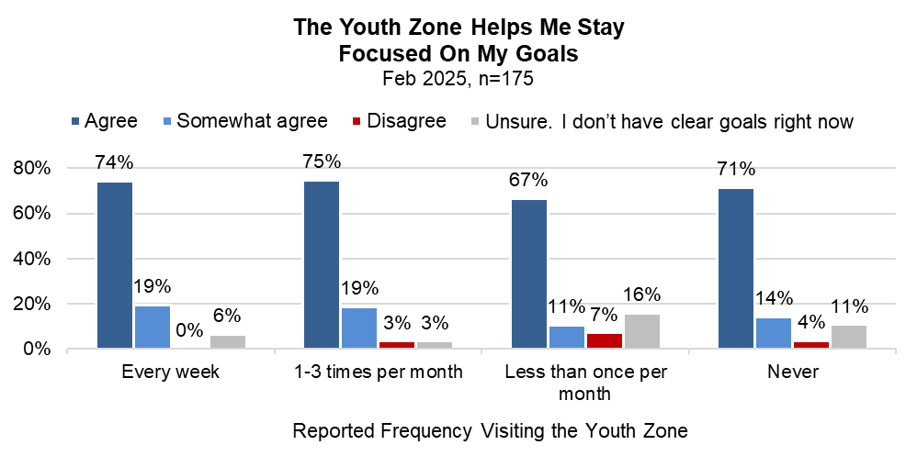

Attendance patterns at the Zone vary by age, with older youth coming more frequently than youth ages 16 to 17. Overall, 18% report attending weekly, 34% one to three times a week, and 32% less than monthly. Seventeen percent of all respondents indicated never visiting the Zone downtown.

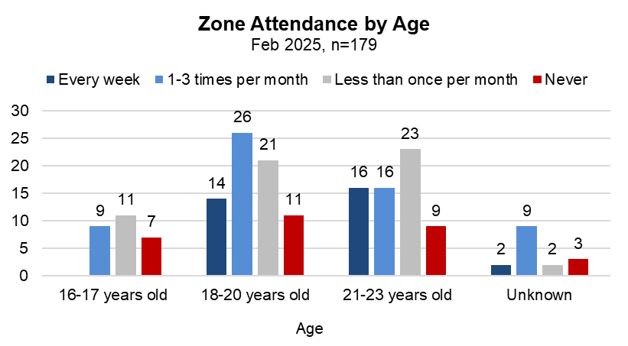

As in prior years, most youth report coming to the 412 Youth Zone downtown to see their coach and to work toward their goals. Half of the youth who come regularly reported coming in for scheduled activities. The other most common reasons are to learn new things, be in a safe space, eat food, and to socialize and see friends. Youth who come to the Zone on a weekly basis come to see their coach and place more value on opportunities to have their basic needs met (safety, food, laundry/shower) than youth who come less frequently. Youth visiting less than once per month are more likely to come to see their coach and access specific services.

What Are the Main Reasons Youth Come to the Youth Zone?
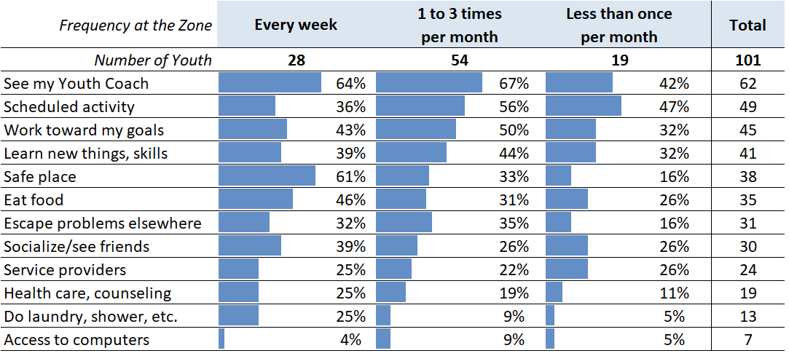

For youth who never visit the Zone, or visit less than monthly, they were asked what would make them want to come more frequently. The most popular response was More Activities That Interest Me. Among these youth, very few provided specific examples instead of simply indicating “more activities.” However, the examples given included career and job opportunities, a library, program to get a car, and regular uncensored studio usage.

Additionally, over a quarter of youth who rarely come indicated they’d be motivated by an invitation from their coach or therapist, and 21 youth indicated that knowing more about the activities would be helpful. The potential impact of direct communication with youth about what happens at the Zone was reinforced by some open text responses which indicated that some youth felt anxiety about coming because they were new or weren’t familiar with the activities.

What Would Make Someone Who Rarely Visits the Zone Want to Come, by Age
 | 16-17 years old | 18-20 years old | 21-23 years old | Total
Total | 18 | 32 | 33 | 83
More activities that interest me | 11 | 13 | 12 | 36
Invitation from Coach¹ | 8 | 7 | 8 | 23
Knowing more about activities | 7 | 6 | 8 | 21
Other: | 2 | 7 | 7 | 16
Too busy to come, daytime activities conflict with work | 1 | 3 | 1 | 5
Transportation, too far away |  | 2 | 2 | 4
¹ One respondent specified they’d be motivated to come by an invitation from their therapist.

Finally, some youth indicated that there was not really anything that would make them want to come more often. Most indicated it was because they were too busy, the Zone was too far away, or they had too many parenting demands. A couple of the youth with these challenges indicated they might attend activities if there was assistance with transportation and more activities scheduled outside of the workday.

Impact of Assistance

Across the core outcome areas in which Youth Zone staff are helping young people make progress, youth reported that their coach or staff at the Zone have most frequently helped them by providing guidance and helping them develop soft skills. 76% of respondents selected at least one of the top three soft skills listed in the chart below, with 60% indicating that Youth Zone staff helped them to think about their future.

Additionally, coaches frequently provided concrete assistance to youth by helping them obtain vital documents, secure their driver’s licenses, access health care, and find or maintain housing. Many of these outcomes were more frequently reported by older youth than among younger youth. However, an increasing number of youth ages 16 to 17 (24%) are identifying assistance with housing as something they’ve received from the Zone.

Ninety-two percent of respondents indicated progress supported by the Zone in at least one area, and 71% reported Youth Zone support making a difference in two or more areas. Of the twelve youth indicating their coach or the Zone has not helped them, seven wrote comments indicating they just started with their coach or haven’t met with them yet.

My Coach or the Youth Zone has Helped Me To… (by Age)
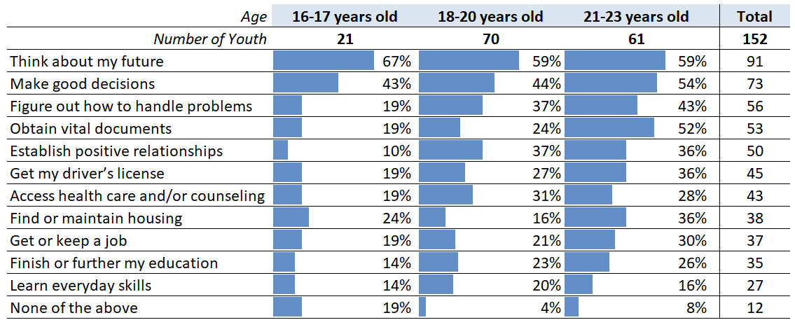

Respondents were asked to rate how often they felt “respected and accepted for who you are” at the Youth Zone, by both staff and their peers. Consistent with patterns from prior years, youth reported feeling more consistently respected by staff than their peers. Consistent with last year, 88% reported they felt respected and accepted by staff Often or All of the Time. Seventy-three percent reported feeling respected and accepted by peers Often or All of the Time.

The demographics of the young people indicating they Rarely or Never felt treated with respect and accepted were examined. The only demographic pattern observed is that the majority (over 80%) of youth indicating they Rarely or Never felt respected and accepted by the staff or their peers were ages 21 to 23. None were younger than age 18.

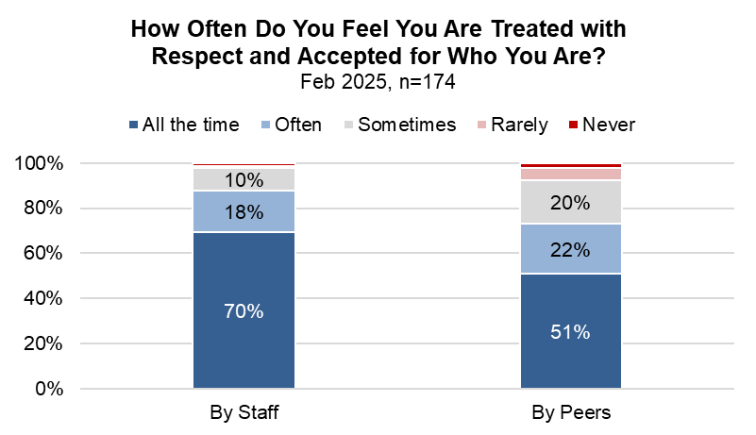

Banking

Participants were asked questions about their use of banks and other ways that they store, receive, and transfer money. Banking practices vary slightly by age, so responses are broken down by age group. Overall, 69% of respondents indicated they have a bank account (compared to 66% in 2023 and 62% in 2024), but only 53% of respondents indicated that they use an account to manage their money. Nearly all youth who report having an account have a checking account, and over half of them also have a savings account.

Overall, the percentages of youth reporting they manage their money by using banking apps and saving money at home both increased since last year. Sixty-five percent of all youth report using banking apps such as Venmo, CashApp, Zelle, etc. Youth who have a bank account but do not use it indicated using these apps as their primary way of managing their money 88% percent of the time.

Banking Status by Age
Age | 16-17 years old | 18-20 years old | 21-23 years old | Total | Percent of Total
Number of Youth | 27 | 72 | 63 | 162 | 100%
Currently have a bank account: | 15 | 43 | 54 | 112 | 69%
Checking account | 15 | 37 | 54 | 106 | 65%
Savings account | 10 | 28 | 26 | 64 | 40%
Had an account in the past | 4 | 12 | 6 | 22 | 14%
Never had an account | 8 | 17 | 3 | 28 | 17%

Methods Youth Use to Store, Receive, and Transfer Money, by Age
Age | 16-17 years old | 18-20 years old | 21-23 years old | Total | Percent of Total
Number of Youth | 27 | 73 | 65 | 165 | 100%
Venmo, Zelle, CashApp, etc. | 20 | 47 | 40 | 107 | 65%
Bank account | 11 | 36 | 40 | 87 | 53%
Saving/storing cash at home | 6 | 18 | 16 | 40 | 24%
PayPal | 2 | 9 | 12 | 23 | 14%
Check cashing service (ex. ACE) | 5 | 9 | 4 | 18 | 11%
Money Order | 2 | 7 | 3 | 12 | 7%

Youth with bank accounts were asked to identify from a list all the different ways they use their account. The table below displays the results, starting with the most common uses, which are saving money and using direct deposit for their sources of income. Young adults ages 21 to 23 more consistently use their bank accounts to save and protect their money, receive direct deposits, and pay bills than younger youth. Youth ages 16 to 17 primarily use their accounts to save money, budget, and keep their money safe.

Ways Respondents Use Their Bank Account(s), by Age
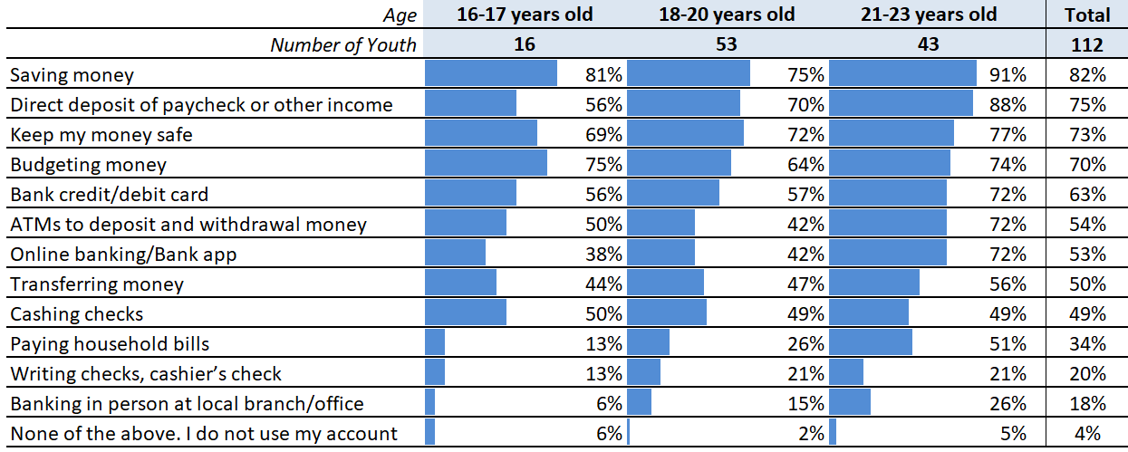

Additional Comments

Finally, youth had the option to share any other comments or feedback they had about the Zone. Nineteen youth provided additional comments. Most took the opportunity to express their gratitude to the Youth Zone in general. A few quotes are included below as examples of some of the responses.

Positive Comments

- Thank you for making me feel safe to open up about my situation
- They are wonderful
- They help me a lot
- I enjoy coming there every time I go
- The Youth Zone is a place in which I feel safe and be myself while having access to resources.
- Keep up the good work🫶🏽

Additional Comments

Only three youth provided feedback on ways the Youth Zone could be improved, which included:

- I feel like you should update us on certain things. I asked for them to find me a driving school still have not found one
- Start making people wash when they smell bad
- I feel like y’all should relocate to a cleaner area

A total of 196 surveys are included in this analysis, including two surveys each from two individuals who completed the survey twice. Each year, duplicates are removed from the dataset by reconciling the different responses a young person provides on different days. For these two youth, their responses varied so significantly that it indicated their life circumstances may have changed during the survey period, so both sets of substantive responses are retained and reported.
This number includes youth who had at least one completed contact, were active with the Zone for at least one month on February 1, and did not close out with the Youth Zone prior to February 21.
Some demographics are missing because the surveys were completed anonymously, and youth were not required to report their demographics. Only 25 youth completed the survey without providing any demographic information.
This response was paraphrased. It was partially illegible.

